**Anaconda Installation Guide for Mac**

1. Go to <https://www.anaconda.com/products/distribution>. Click on the download button on the right-hand side.

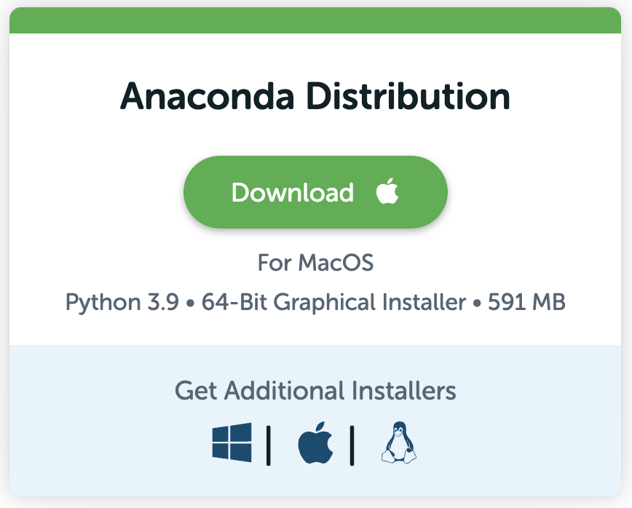

1. A file named **Anaconda3-2022.05-MacOSX-x86_64.pkg** (or the latest version)will be downloaded.
2. Double click the **Anaconda3-2022.05-MacOSX-x86_64.pkg** fileto install Anaconda.

Use the default settings of the installer.

The installation may take a few minutes.

**To start editing and executing Python code using Jupyter Notebook:**

1. After installing Anaconda, go to the launch pad and search for Anaconda Navigator.

1. Click the Launch Button in the Jupyter Notebook rectangle.

You should see the following screen on your default browser (recommended default browser : Google Chrome)

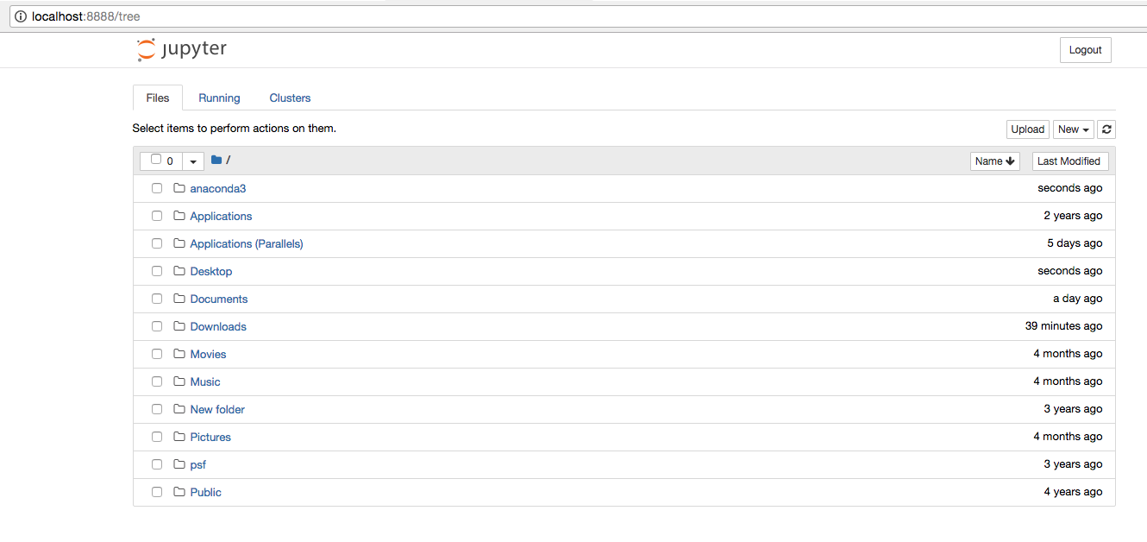

Note:

If you use Chrome for the first time while opening Jupyter Notebook, you may encounter the following screen. Don’t worry!

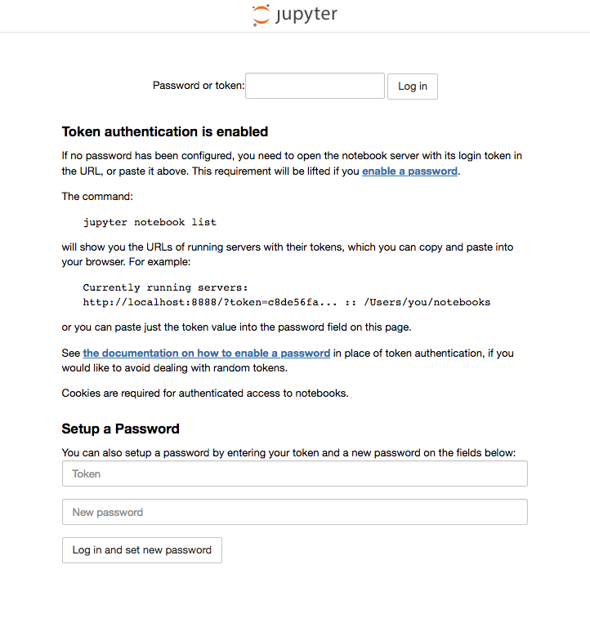

Just go to the command prompt window below, copy the **token number** and paste it inside the above text box. Then press the **Log in** button. That is all!

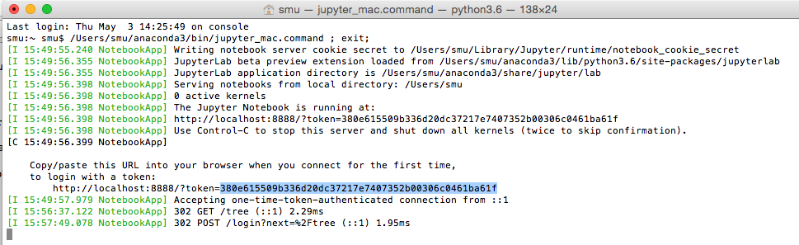

The Jupyter Notebook environment can be used to edit and execute Python code.

More details will be given to you in class during the session.

**You are done with the installation!**

If you face issues in installing, please let us know before the lessons or during the first lesson so that we can help solve the issue.

See you soon!